**1. Register**

**2. Sign in**

**3. Change password**

**4. Update account info**

**5. Reset password**

**6. View login history**

**7. Auto-unlock after time**

- Tài khoản nhập sai mật khẩu quá 3 lần:

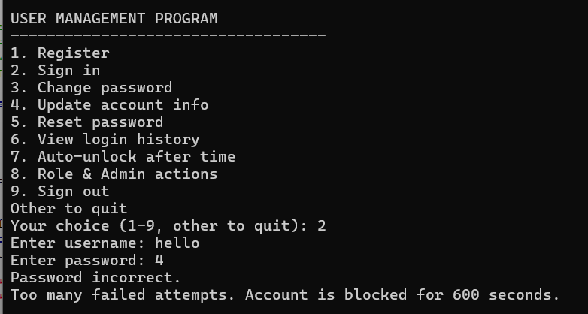

**8. Admin**

**-** Các chức năng của admin:

**9. Sign out**

